|  |  |
| --- | --- |
| SanTan  Website Theme  (Assignment 1) | submitting TO:  Doug MacKenzie  Saloni Gupta  27044722 |

Table of Contents

[Project Outline 2](#_Toc511302727)

[Site Outline 2](#_Toc511302728)

[Scope 2](#_Toc511302729)

[Development methodology 2](#_Toc511302730)

[Wireframe 3](#_Toc511302731)

[Home Page 3](#_Toc511302732)

[About Us 3](#_Toc511302733)

[Graphical user interface design 4](#_Toc511302734)

[Graphical representation of website 4](#_Toc511302735)

[Storyboard 5](#_Toc511302736)

[Design style 6](#_Toc511302737)

[font style 7](#_Toc511302738)

[weights 7](#_Toc511302739)

[Colour 7](#_Toc511302740)

[Measurements 8](#_Toc511302741)

[Banner 8](#_Toc511302742)

[Logo 8](#_Toc511302743)

[Site Map 9](#_Toc511302744)

[Form Page Designs 10](#_Toc511302745)

[Contact Form / Appointment request Form 10](#_Toc511302746)

[Sign in/ up Form 10](#_Toc511302747)

[Database Design 11](#_Toc511302748)

[Data model designed 11](#_Toc511302749)

[Tables 11](#_Toc511302750)

[Records 12](#_Toc511302751)

[References 14](#_Toc511302752)

# Project Outline

## Site Outline

This report describes a website development process for a company website. Moreover, I have explained all the details of the website. Here, I assume a hypothetical client, that is Rotorua pulse. Which provides complete guidance on Rotorua and its famous places to visit. Now they want to digitalize their system. That is why I am here to make a website for them. I am making new theme for this, name SanTan. So, it is version 1 of SanTan theme combine with some details of the company contents. The theme is compatible with client’s requirements.

## Scope

Rotorua pulse requires a full website. This will explore client’s work to the world. Furthermore, event news, social feed features will add a cherry on the cake. Client can publish regular events and functions on website. So that customers can see and come and enjoy. Site will have register and login facilities. Moreover, customer can book an appointment or contact them using appointment form. As a result, it will be fully functional website for my client.

## Development methodology

I choose scrum methodology to develop this website. Scrum is a part of agile method. It is for one to four weeks project work. However, it works weekly as well as daily. Project members divide works in scrums with do, doing and done lists. There are daily and weekly scrums which define the workflow of each members. Scrum master manages the team members and their activities. Manager scold’s member whenever they don’t work as per the scrum and give relaxation time when they are ready with their work before time. At the end of the day they discuss what has been done and what will be the next work to do. (ITknowledge, 2017)

This is very simple and easy to implement. As a single member, I am also able to work accordingly. I have done a worksheet to show my scrum activities and progress.

# Wireframe

Here is some wireframe work for SanTan theme. I made it online from website. (mokeflow, 2009) Which provides free version to make a wireframe for only one project.

## Home Page

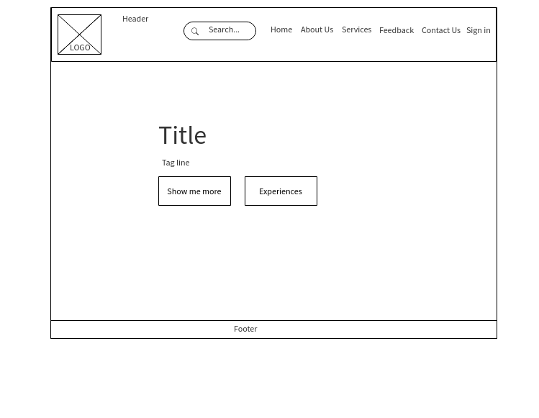

## About Us

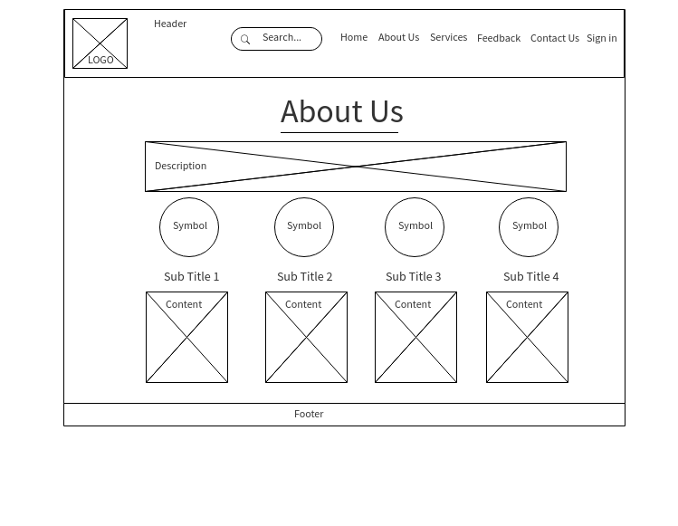

# Graphical user interface design

## Graphical representation of website

santan\_27044722 /

|\_\_ Assets/

|\_\_ Development/

|\_\_ [index.php](../development/index.php)

|\_\_ [index.html](../development/index.html)

|\_\_ [privacy\_policy.php](../development/privacy_policy.php)

|\_\_ css/

|\_\_ [style.css](../development/css/style.css)

|\_\_ images/

|\_\_ js/

|\_\_ [script.js](../development/js/script.js)

|\_\_ lib/

|\_\_ bootstrap/

|\_\_ css/

|\_\_ [bootstrap.min.css](../development/lib/bootstrap/css/bootstrap.min.css)

|\_\_ [bootstrap-theme.min](../development/lib/bootstrap/css/bootstrap-theme.min.css)

|\_\_ font-awesome/

|\_\_ css/

|\_\_ [font-awesome.min](../development/lib/font-awesome/css/font-awesome.min.css)

|\_\_ demo/

|\_\_ [demo.html](../demo/demo.html)

|\_\_ [demo.css](../demo/demo.css)

|\_\_ Documents/

|\_\_ <project_report.docx>

|\_\_ [scrum.xlsx](Scrum.xlsx)

|\_\_read\_me.txt

## Design Style

**Full view of the website**

Homepage:

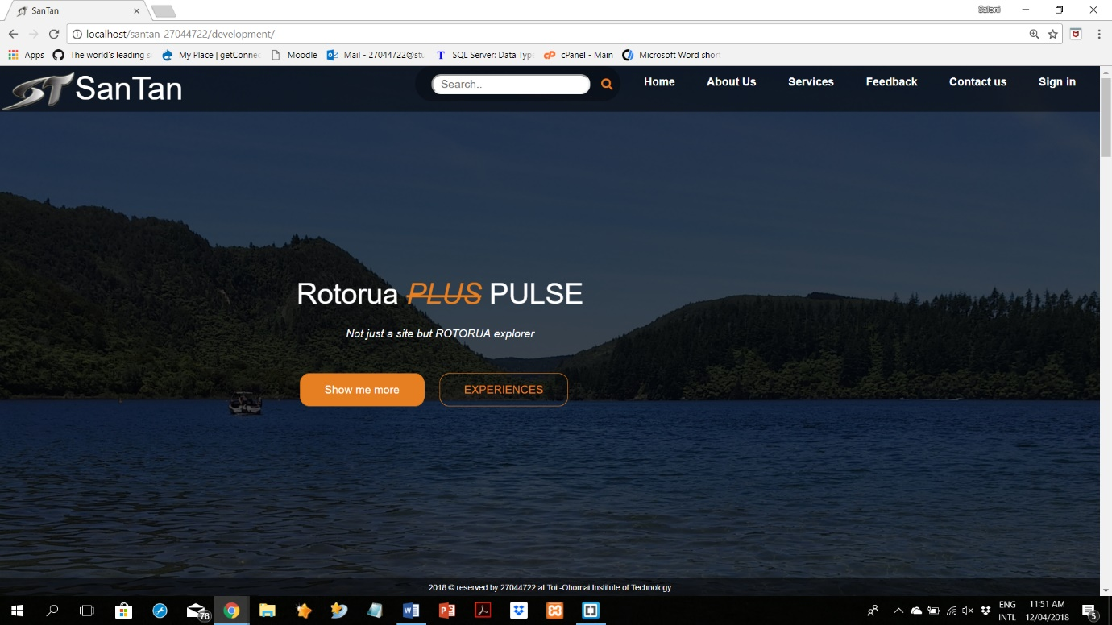

About Us Page:

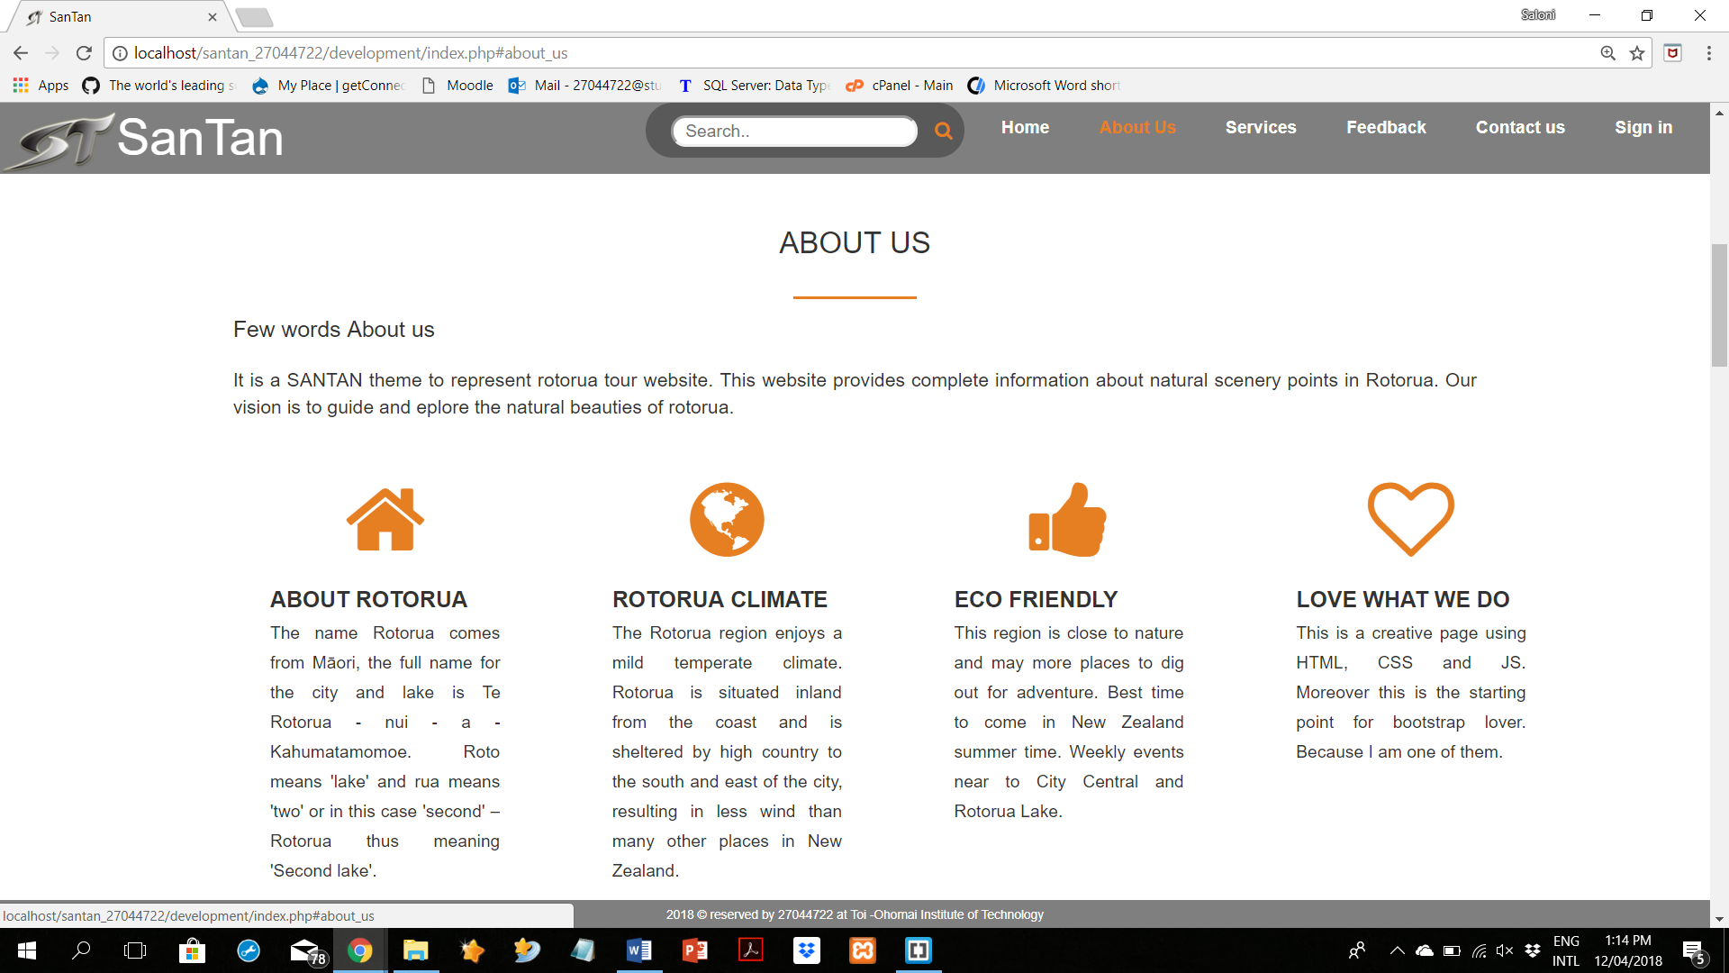

**Full view of the website**

|  |  |
| --- | --- |
| HomePage: | About Us Page: |
|  |  |

## Design style

I made this design by learning from w3schools and a video named (How to create a Responsive website using Html 5 , Css3 and Bootstrap, 2016). For Designing purpose, I made CSS file using CSS3. Also, I add bootstrap package for standard mobile responsive website. (Bootstrap, 2018) I use font awesome to add some icons to the website. (Font Awesome, 2017). To provide some functions I made JavaScript file.

I made fix menu bar using boot strap. Then convert that menu bar to responsive one using JavaScript. For that I use reference from w3schols (How TO - Responsive Top Navigation, n.d.).

***First webservice: google map***

I add google map using google API. I use java script program to add google map and its search bar. (google Maps APIs, n.d.) Furthermore, I change decimal latitude and longitude coordinates in that js. And I added working search bar for this map using same reference.

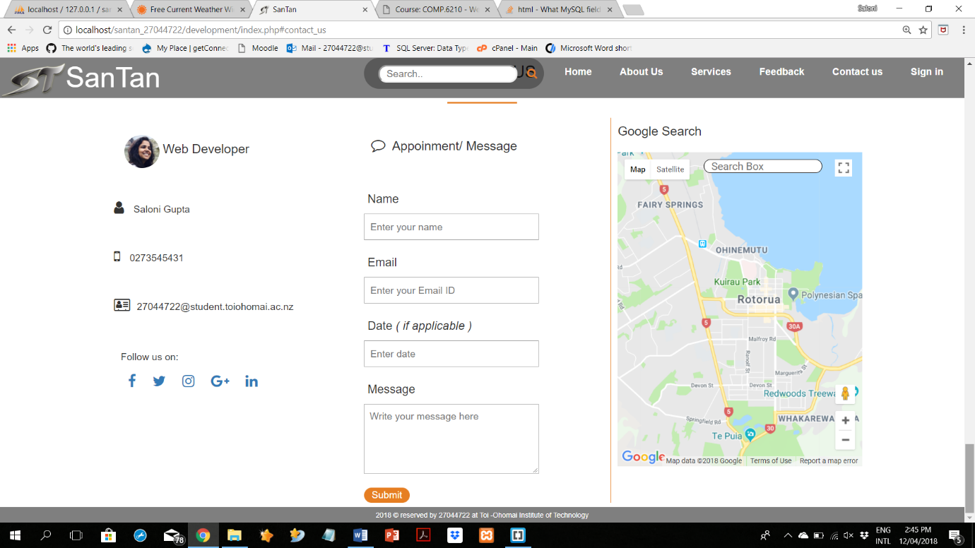

***Second webservice: weather widget***

I used a widget code from (AccuWeather, 2018).

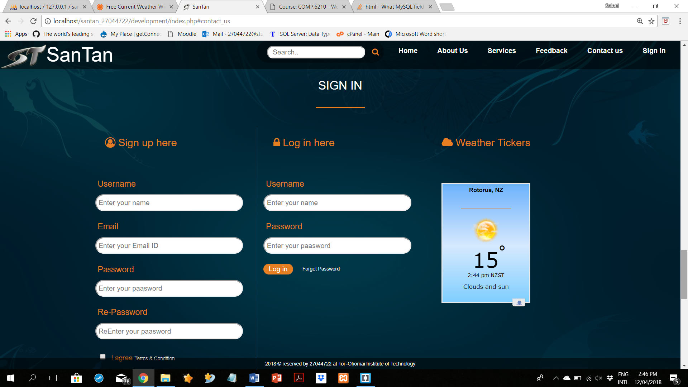

***Third webservice: twitter news feed***

I used a widget code from my own twitter account with the help of information blog of twitter. (twitter, 2018)

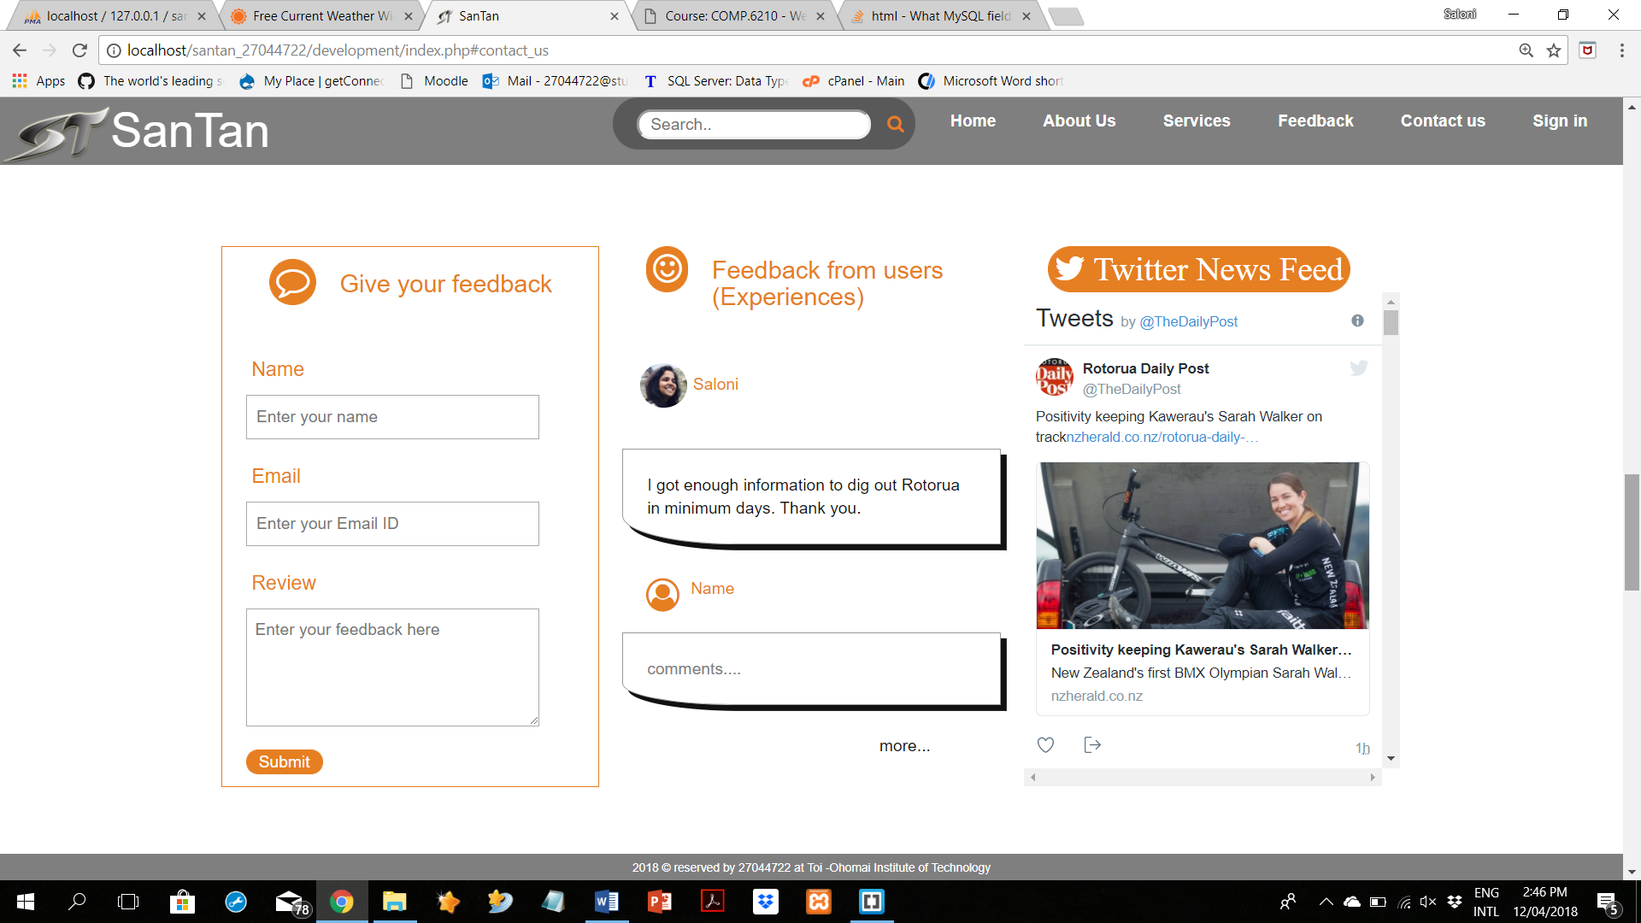

## font style

In general: font-family -> sans-serif

Ex: Not just a site but ROTORUA explorer

h1, h2, h3, h4, h5, h6: font-family -> sans-serif (Poppins)

Ex: SanTan

## weights

In general, h1, h2, h3, h4, h5, h6: font-weight -> 400

In navigation bar, all link has font-weight -> 600

In about-us page, subtitle: font-weight -> 600

In service page, subtitle: font-weight -> 700

## Colour

Colour combination:

Each link/ button has this colour combination alternatively. That means If link/button is white then on hover effect it will become orange and visa-versa. By default, there is colour black in texts. But when we have different backgrounds then, text-colour became white. Logo colour is grey.

|  |  |  |
| --- | --- | --- |
| **Colour** | **Code** | **Sample** |
| Black | #111 |  |
| White | #fff |  |
| Tahiti Gold (approx.) | #e67e22 |  |
| Grey | #808080 |  |
| Opacity colour | rgba (0,0,0,0.7) |  |
| Opacity colour | rgba (0,0,0,0.3) |  |

## 

## Measurements

This design is compatible for every device, mobile devices as well. So, the width and height of the content is 100% of device width and height.

## Banner

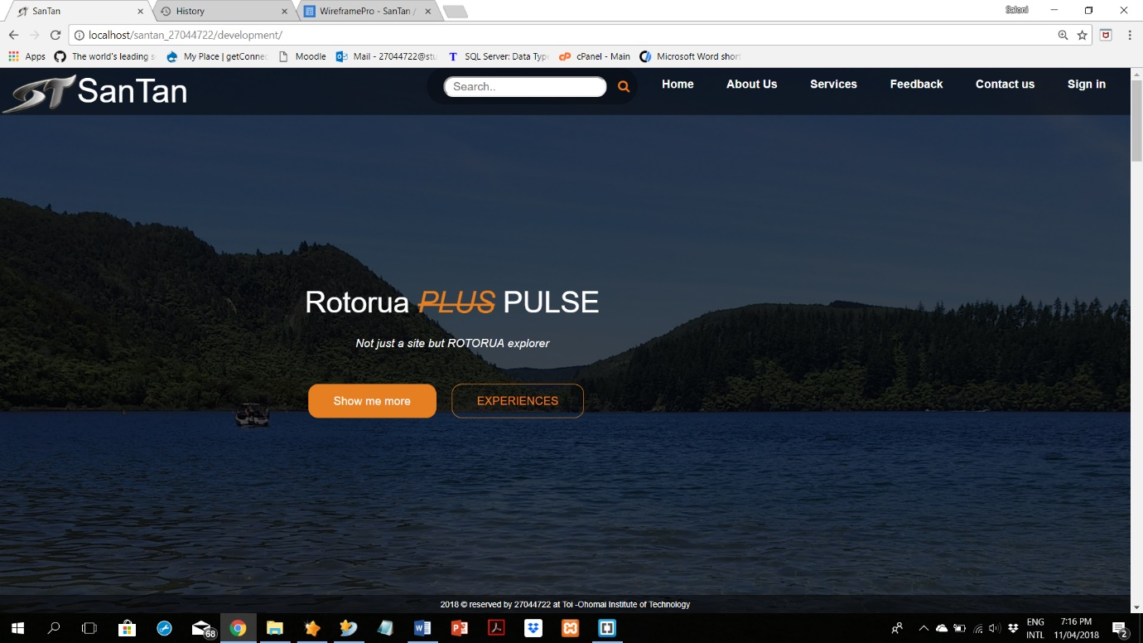

## Logo

Here, there is a logo for my theme SanTan, which is in two colours black and grey. As I assume a client for my work. I make just a sample logo for my website theme.

Main logo: 

## Images

Profile image:

This photo is clicked by friend.



Header background image:

This is a photo of blue lake which is clicked by me.

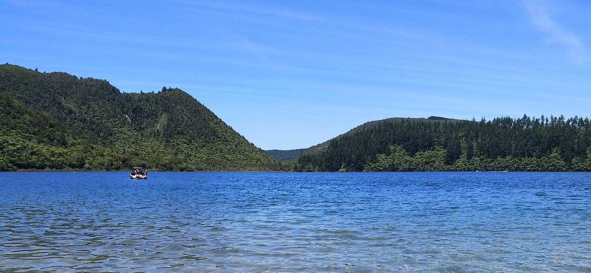

Background image for services and login page:

This is taken from web. (backgroundcheckall)



# Site Map

Index.php

Search

Home

Index.php

Weather tickers

Sign in / Sign up form

Twitter News Feed

Feedback form

Google Map

Message / Appointment form

Terms and Condition

privacy\_policy.php

Sign In

#sign\_in

Contact Us

#contact\_us

Feedback

#feedback

Services

#services

About Us

#about\_us

# Form Page Designs

|  |  |
| --- | --- |
| Contact Form / Appointment request Form | Sign in/ up Form |
| https://s3.amazonaws.com/assets.mockflow.com/app/wireframepro/company/C93aa9c21a629ceeac838adbbd522d24b/projects/Dbe9d0b518305f5e36a5d064d104c92cb/pages/2851f3a931874b6bb04a38112a1946ff/image/2851f3a931874b6bb04a38112a1946ff.png | https://s3.amazonaws.com/assets.mockflow.com/app/wireframepro/company/C93aa9c21a629ceeac838adbbd522d24b/projects/Dbe9d0b518305f5e36a5d064d104c92cb/pages/2851f3a931874b6bb04a38112a1946ff/image/2851f3a931874b6bb04a38112a1946ff.png  https://s3.amazonaws.com/assets.mockflow.com/app/wireframepro/company/C93aa9c21a629ceeac838adbbd522d24b/projects/Dbe9d0b518305f5e36a5d064d104c92cb/pages/2851f3a931874b6bb04a38112a1946ff/image/2851f3a931874b6bb04a38112a1946ff.png |

# Database Design

## Data model designed

Database: SanTan

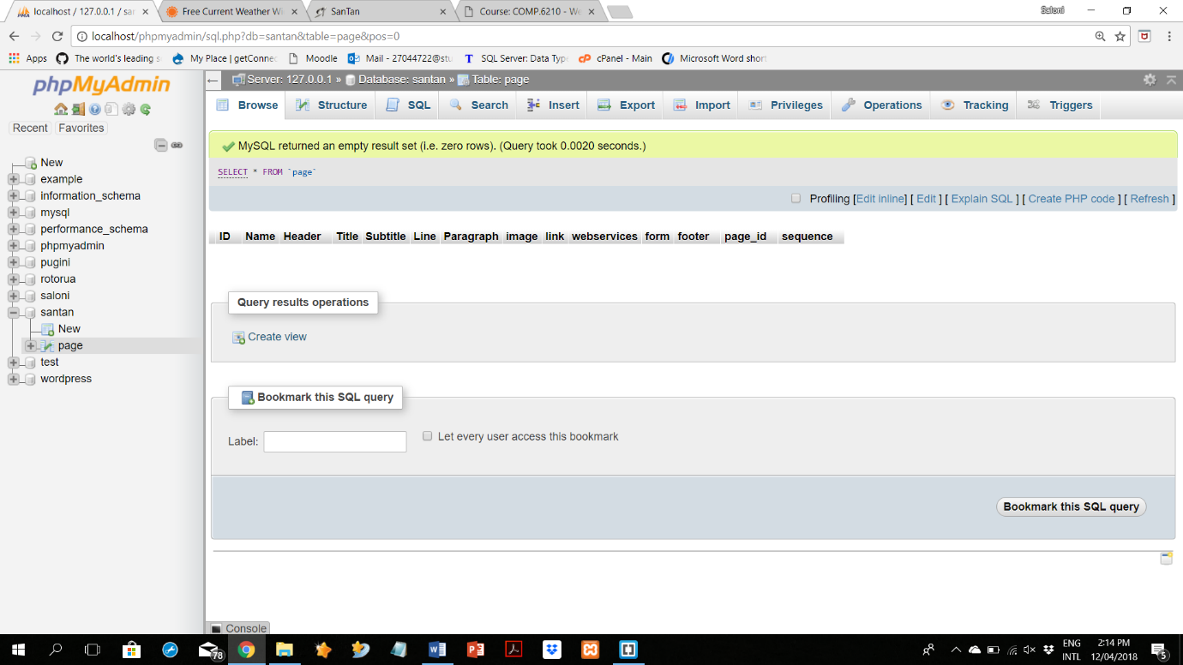

## Tables

Table: Page

|  |  |  |  |
| --- | --- | --- | --- |
| **No** | **Field name** | **No** | **Field name** |
| 1 | ID | 8 | Image |
| 2 | Name | 9 | Link |
| 3 | Header | 10 | Webservice |
| 4 | Title | 11 | Form |
| 5 | Subtitle | 12 | Footer |
| 6 | Line | 13 | Page\_ID |
| 7 | Paragraph | 14 | Sequence |

## Tables in SQL

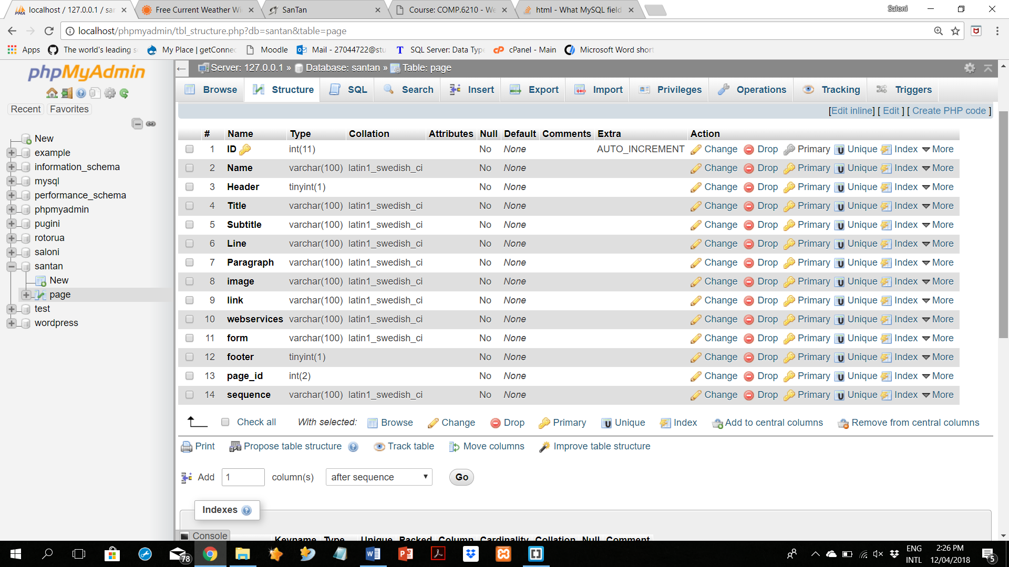

## Records

Table Name: Page

|  |  |  |  |  |  |  |  |
| --- | --- | --- | --- | --- | --- | --- | --- |
| **No** | **Field** | **Record: 1** | **Record: 2** | **Record: 3** | **Record: 4** | **Record: 5** | **Record: 6** |
| 1 | **ID** | 1 | 2 | 3 | 4 | 5 | 6 |
| 2 | Name | Home | About-Us | Services | Feedback | Contact-Us | Sign-in |
| 3 | Header | Yes | Yes | Yes | Yes | Yes | Yes |
| 4 | Title | Rotorua Pulse | About Us | Services | Feedback | Contact-Us | Sign-in |
| 5 | Subtitle | - | About Rotorua, Rotorua climate | Lake view, Hot pools | Give your Feedback | Google Search | Log in here |
| 6 | Line | Tag line | - | - | - | - | - |
| 7 | Paragraph | - | The name Rotorua…., The Rotorua region…. | There are different…., This is extra ordinary…. | - | - | - |
| 8 | Image | Logo | - | - | Profile | Profile | - |
| 9 | Link | - | - | - | - | Social sites | Privacy policy |
| 10 | Webservice | - | - | - | News-feed | Google map | - |
| 11 | Form | - | - | - | Feedback | Message | Sign in, Sign up |
| 12 | Footer | Yes | Yes | Yes | Yes | Yes | Yes |
| 13 | **Page\_ID** | 11 | 12 | 13 | 14 | 16 | 15 |
| 14 | Sequence | 3, 4, 6, 8, 12 | 3, 4, 5, 7, 12 | 3, 4, 5, 7, 12 | 3, 4, 5, 7, 11, 10, 12 | 3, 4, 5, 8, 9, 11, 10, 12 | 3, 4, 5, 11, 9, 12 |

## Records in SQL

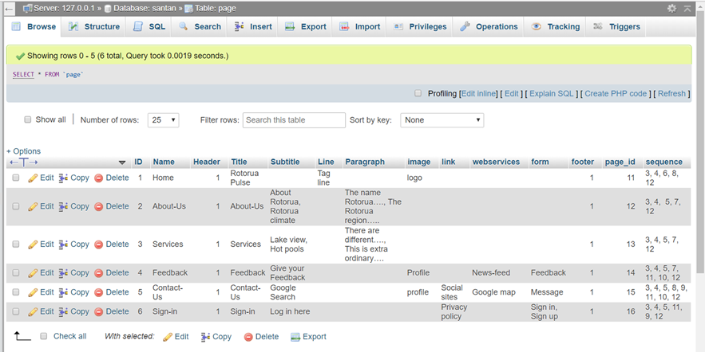

## SQL Queries

Insert query:

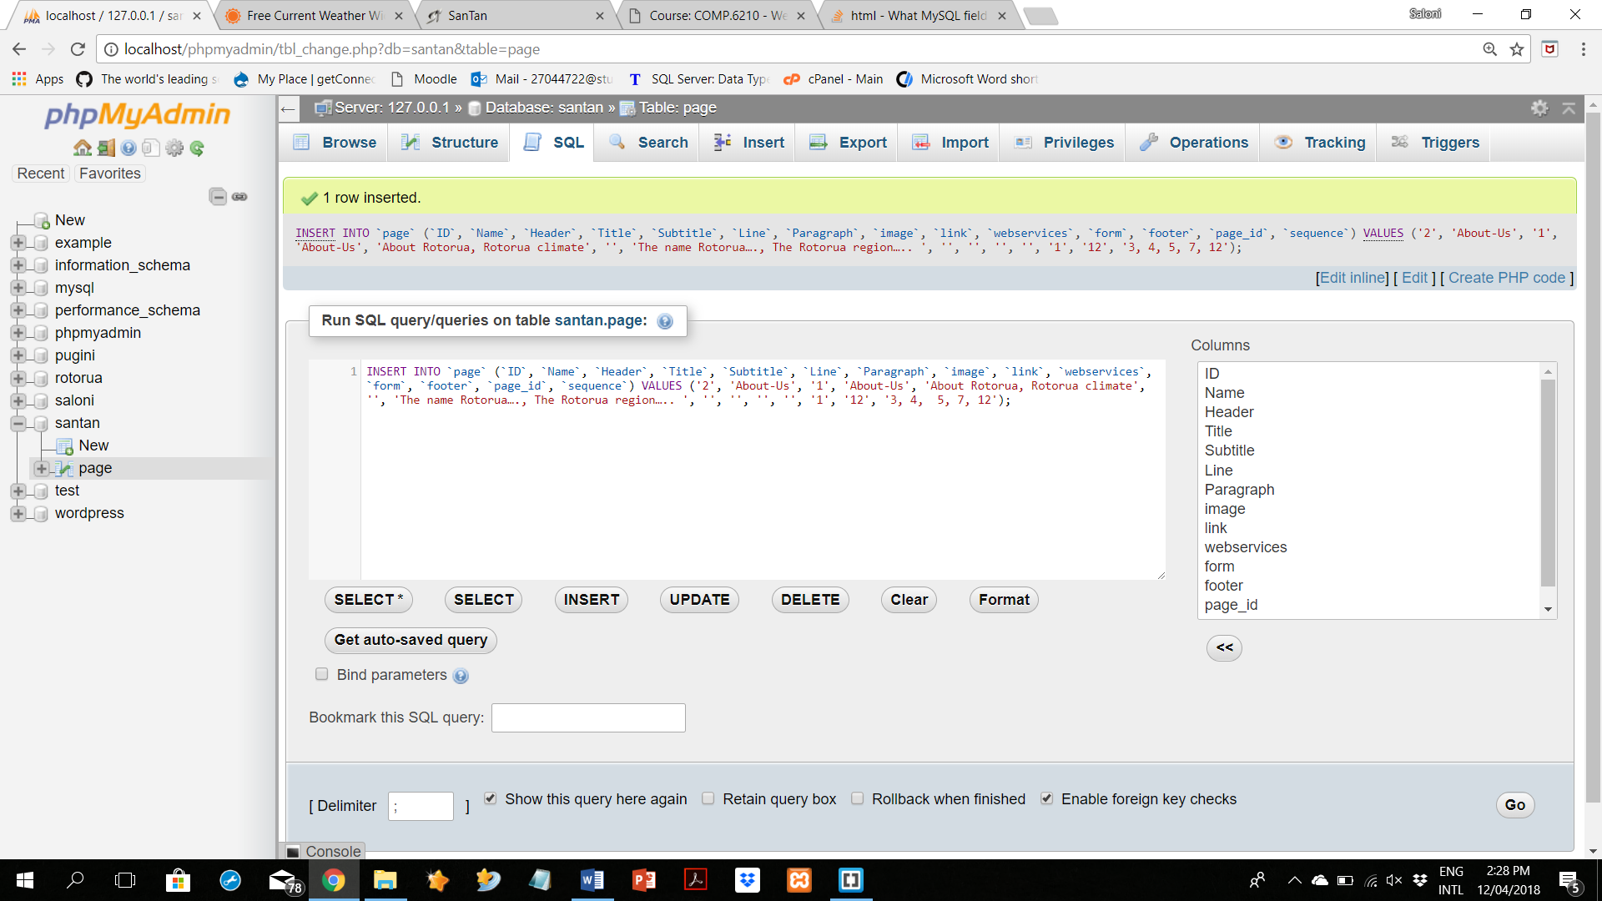

Update query:

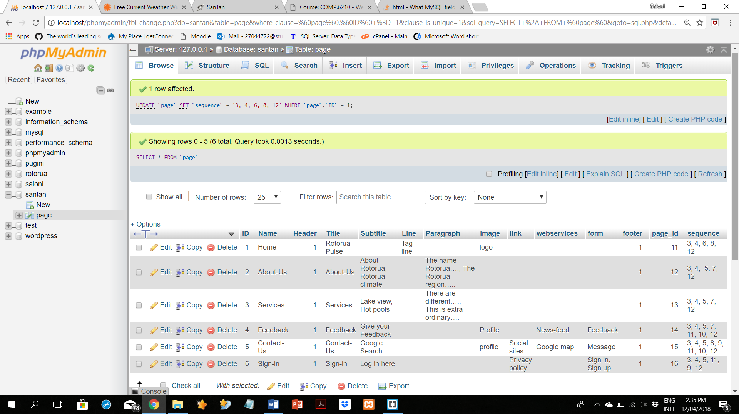

Select query:



# References

*AccuWeather*. (2018). Retrieved from AccuWeather: https://www.accuweather.com/en/free-weather-widgets/current

*backgroundcheckall.* (n.d.). Retrieved from http://backgroundcheckall.com/: http://backgroundcheckall.com/wp-content/uploads/2017/12/login-page-background-images-hd-10.jpg

*Bootstrap*. (2018). Retrieved from Bootstrap: https://getbootstrap.com/docs/4.0/getting-started/download/

*Font Awesome*. (2017). Retrieved from Font Awesome: https://fontawesome.com/

*Google cloud platform*. (n.d.). Retrieved from https://console.cloud.google.com/iam-admin/iam

*google Maps APIs*. (n.d.). Retrieved from Places search box: https://developers.google.com/maps/documentation/javascript/examples/places-searchbox

*How TO - Responsive Top Navigation*. (n.d.). Retrieved from w3schools: https://www.w3schools.com/howto/howto\_js\_topnav\_responsive.asp

*How to create a Responsive website using Html 5 , Css3 and Bootstrap* (2016). [Motion Picture]. Retrieved from https://www.youtube.com/watch?v=wVvhqJBcmcg&t=1281s

ITknowledge. (2017). *Software Development Methodologies*. Retrieved from IT knowledge Portal: http://www.itinfo.am/eng/software-development-methodologies/

*mokeflow*. (2009). (A Produle Systems Pvt Ltd) Retrieved from mokeflow: https://wireframepro.mockflow.com

*twitter*. (2018). Retrieved from twitter: https://help.twitter.com/en/using-twitter/embed-twitter-feed